Big Mountain Resort – Insights & Recommendations

1. Below are the histogram distributions for all columns in the dataset for Ski mountain resort.

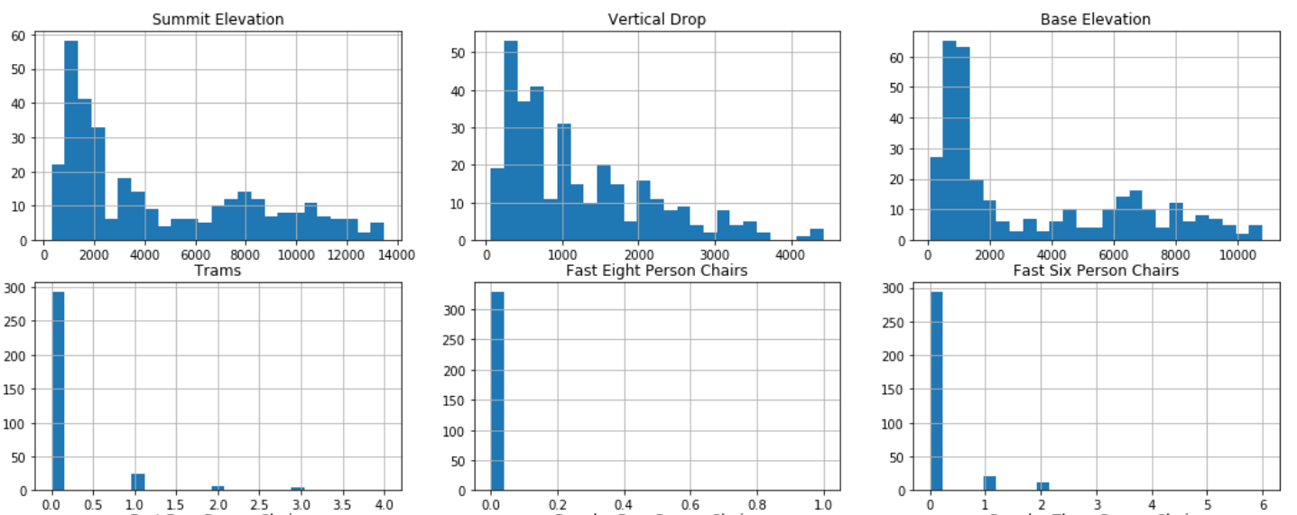

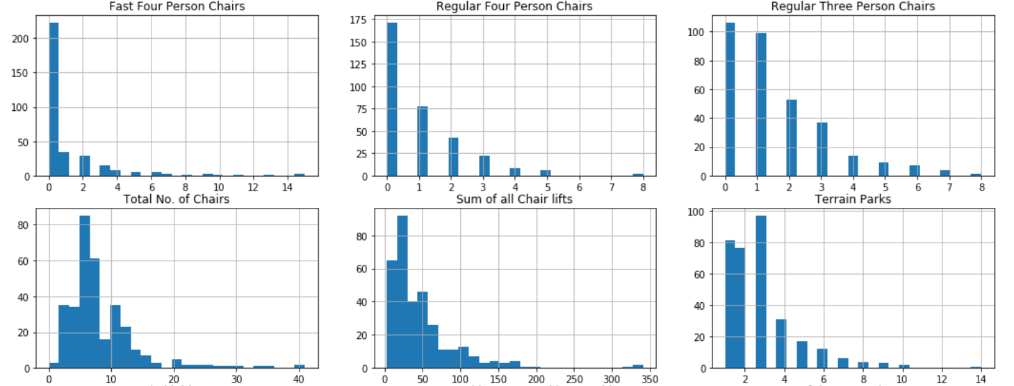

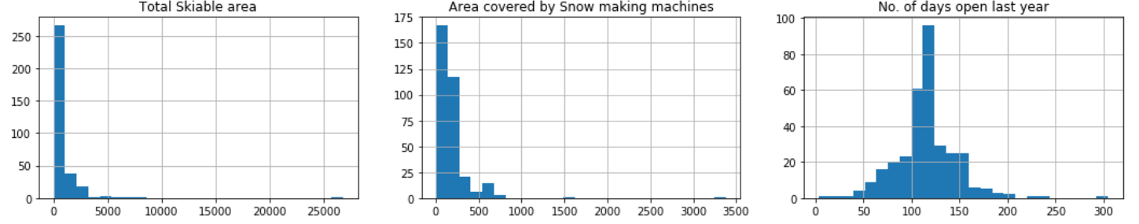

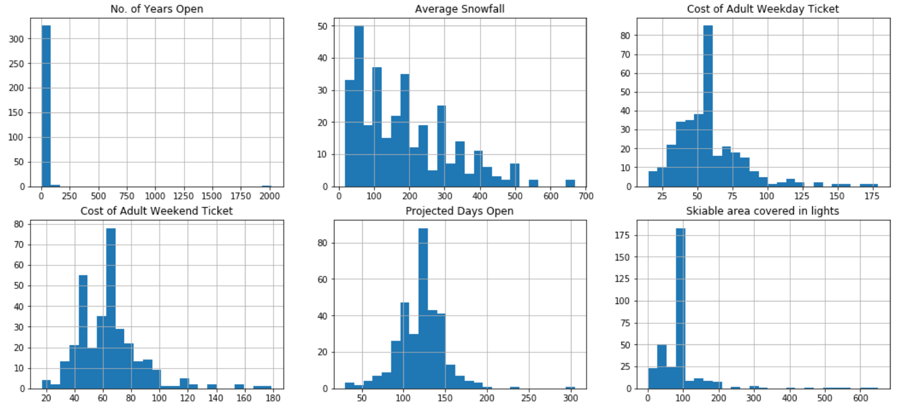

From the Distribution graphs, it can be concluded that

* Distributions for Summit Elevation and Base Elevation are similar and thus could be highly correlated.
* Distributions for Cost of Adult Weekend Ticket and Adult Weekday Ticket are similar

1. Bar plots for ‘Region’ and ‘State’ columns indicate that both are almost same columns with slight differences. So, I dropped the ‘Region’ column.
2. Then I went ahead and drew a Correlation Matrix for all numeric columns and found columns for which correlation is > 0.95. Base Elevation has a correlation with Summit Elevation of > 0.95 and thus I decided to drop it from the dataset.
3. I went ahead and built 3 different models of Linear Regression (making slight logical variations of the dataset) by dividing the dataset into Training set and Test set ratio of 75:25.
   1. I evaluated the models in terms of Explained Variation and Mean Absolute Error and below were the findings –

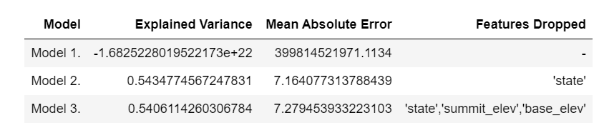

* 1. Model 2 is selected as it has higher Explained Variance and lower Mean Absolute Error than Model 3, I used the coefficients from the Linear Regression model to find out the top features/columns that are driving Adult Weekend Prices (Dependent Variable).

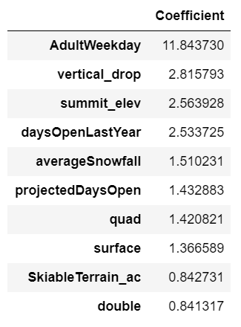

1. Thus, the recommendation to the Big Mountain Resort Management is to focus on the highlighted columns in order to increase their revenues for recovering the operating costs keeping Profit margins constant.
2. While not all the features are in control for the Management to make any changes (for e.g. Vertical Drop, Summit Elevation, Average Snowfall, Skiable Terrain), the Management can definitely look at – **Adult Weekday Prices, days open last year, projected days open, count of regular speed 4 chairs, count of regular speed single chairs, count of regular speed two chair lifts and increase them**.